Portable Electric Power Tilling Machine

Agriculture has been an integral part of the human ecosystem. However, traditional farming methods require a lot of human effort and are very time-consuming. Farm tilling is one of the most labor intensive operations in agriculture. Manual tiling of fields is very strenuous task while tractors incur high capital along with heavy fuel consumption costs.
This low-cost portable battery charged electric power tiller machine is a one-stop modern solution to enhance the conventional agriculture methods of farming, as it reduces the human effort, at a very negligible price using motorized tilling mechanism. The electric power tiller helps reduce the time and cost involved in tilling using a smart portable design thereby increasing the productivity and efficiency in agriculture.
The Portable Electric Power Tiller delivers a load of advantages including:
- Automatic Operation
- Battery Powered No Fuel Needed
- Portable and easy to operate
- Cost-effective as compared to a tractor
- Replacement for animal power & human effort.
- Reduces tilling time

The machine makes use of a wheel with welded angles to provide efficient gripping on soil. The wheel design is developed to provide a firm grip on soil strong enough to drag the cultivator forks while tilling process. A switch provided on the handle is used to switch on off the machine. The machine is driven by an electric motor which uses a sprocket chain arrangement to drive the pulling wheel.
A battery is used to power the motor with a force capable of pulling the forks through soil. The 3 x cultivator forks allow for easy and narrow tilling exactly as needed for farming. The portable lightweight design makes it easy to control the direction of machine while in use. Also it can be easily carried around in vehicles or by hand for transporting the machine. Thus the electric power tiller provides a smart innovative fuel free mechanism to farm and garden tilling.

Components:
- Electric Motor
- Bicycle Wheel
- Chain Sprokets
- Wheel Angles
- Bearing
- Shaft
- Battery
- Switch
- Electrical & Wirings
- Mounts and Joints
- Supporting Frame
- Screws and Fittings

Applications:
- Farming
- Gardening

Advantages:
- Automatic Operation
- Battery Powered No Fuel Needed
- Portable and easy to operate
- Cost-effective as compared to a tractor
- Replacement for animal power & human effort.
- Reduces tilling time

Disadvantages:
- It needs charging when battery runs out
- It cannot perform other farming processes

Block Diagram:

Front View
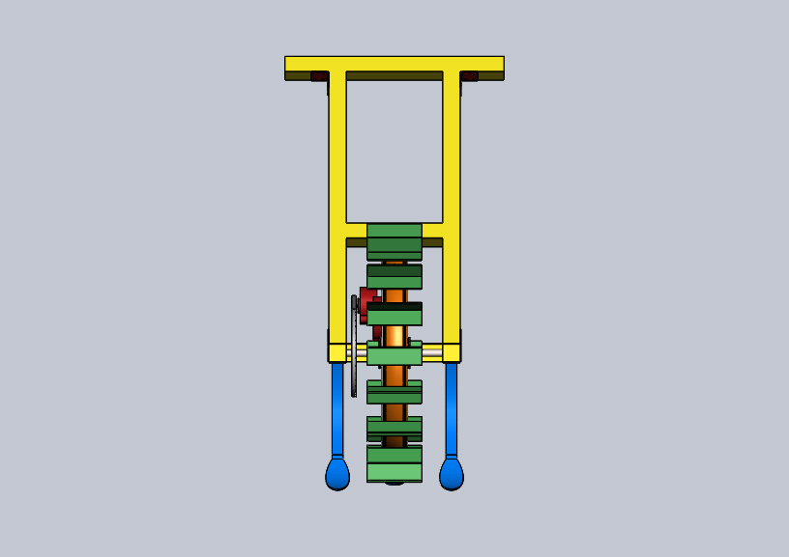
Side View
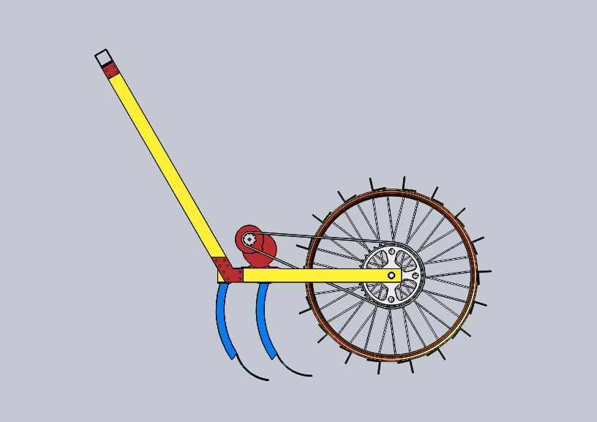

3D View

